**Quality Assurance Project Plan**

**Puget Sound High Resolution Change Detection**

Grants PC00-J27601-4, IAA No. C1300191

November 2013

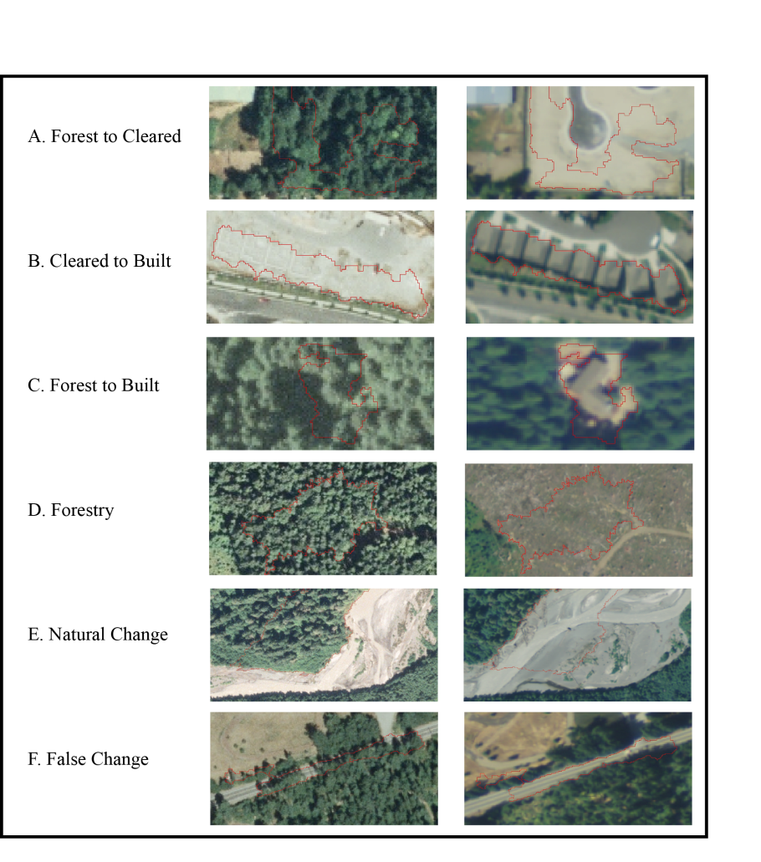

Prepared by:

Kenneth Pierce, PhD

Washington State Department of Fish and Wildlife

Prepared for:

Washington State Department of Ecology and

US Environmental Protection Agency

**Publication Information**

Studies conducted for the Washington State Department of Ecology (Ecology) and/or U.S. Environmental Protection Agency (EPA) that involve analysis of environmental data must have an approved Quality Assurance (QA) Project Plan (QAPP). The purpose of this QAPP is to describe how the WDFW uses satellite and aerial images to detect and map land use changes in the Puget Sound basin watersheds. This change detection analysis is being funded in part by the EPA’s National Estuary Program (NEP) via an interagency agreement with the Ecology as the lead organization for *Watershed Protection and Restoration* grants. However, contents of the QAPP do not necessarily reflect the views and policies of the EPA, nor does mention of trade names or commercial products constitute EPA endorsement or recommendation for use.

This QAPP, any addenda to it, and final reports will be made available on the WDFW internet website (http://wdfw.wa.gov/conservation/research/projects/aerial_imagery/index.html). Additional information about the project and detailed results will be available on request from the author.

**Author and Contact Information**

Ken Pierce PhD

Landscape Spatial Analyst

[Kenneth.piercejr@dfw.wa.gov](mailto:Kenneth.piercejr@dfw.wa.gov)

360 902-2564

Washington Department of Fish & Wildlife

**Quality Assurance Project Plan**

**Puget Sound High Resolution Change Detection**

**November 2013**

**Approved by:**

|  |  |  |
| --- | --- | --- |
| Signature: |  | Date: |
| Ken Pierce, Principal Investigator, WDFW |  |  |
| Signature: |  | Date: |
| Timothy Quinn, Habitat Chief Scientist, WDFW |  |  |
|  |  |  |
| Signature: |  | Date: |
| Kim Harper, Grant Manager, Ecology |  |  |
|  |  |  |
| Signature: |  | Date: |
| William Kammin, QA Officer, Ecology |  |  |

**Table of Contents**

SECTION A Project Management 6

A-3 Distribution List 6

A-4 Project/Task Organization 6

A-5 Problem Definition/Background 6

A-6 Project/Task Description 7

Phase I 7

Phase II 7

A-7 Quality Objectives and Criteria 8

A-8 Certification 9

A-9 Documentation 9

Section B: Measurement/Data Acquisition 10

B-1 Sampling Process Design 10

B-2 Sampling and Acquisition Methods 10

B-3 Sample Handling and Custody 10

B-4 Analytical Methods 10

B-5 Quality Control 13

B-6 Instrument testing 13

B-7 Instrument calibration 13

B-8 Inspection/Acceptance for supplies 13

B-9 Data Acquisition (Nondirect Measurements) 13

B-10 Data Management 14

Group C: Assessment/Oversight 14

C-1 Assessments and Response Actions 14

C-2 Reports to Management 14

Group D: Data Validation and Usability 14

D-1 Data Review, Verification, and Validation 14

D-2 Verification and Validation Methods 15

D-3 Reconciliation with User Requirements 15

References (Including those from Appendix B) 16

Appendix A – Abbreviations, Common Acronyms, and Glossary 20

Appendix B Methods Excerpt from manuscript in preparation 21

2. Methods 21

2.1 Mapping “change events” 21

2.2 Image data processing 24

2.3 Land Cover modeling 25

2.4 Segment generation 28

2.5 Round 1 training data and the AAViewer 31

2.6 Statistical predictions with Random Forests 35

2.7 AA Procedures –Eliminating Commission 37

2.8 AA Procedures- Estimating Omission 39

2.9 Land cover mapping accuracy 40

2.10 Analysis of change polygons 41

Appendix C – HRCD Analysis Tracking Spreadsheet 42

# SECTION A Project Management

## A-3 Distribution List

Ken Pierce

Principal Investigator

WA Dept. of Fish & Wildlife

1111 Washington St SE

Olympia, WA 98503

Timothy Quinn

Habitat Chief Scientist

WA Dept. of Fish & Wildlife

1111 Washington St SE

Olympia, WA 98503

Kim Harper

WA Department of Ecology

Project Lead - NEP Watershed Protection & Restoration Grant

WA State Department of Ecology

Northwest Regional Office

3190 160th Ave SE

Bellevue, WA 98008-5452

## A-4 Project/Task Organization

High definition change detection (HRCD) analysis will be conducted by WDFW staff in the Habitat Science Landscape Spatial Analytics Section under the direction of Ken Pierce PhD.

## A-5 Problem Definition/Background

Land-use/land-cover is a key data element for environmental management vital to both science and planning. Current spatial data products derived from Landsat satellite data lack the resolution to effectively capture landscape elements smaller than ~2 hectares (ha) (Robert Gilmore Pontius et al., 2007). Human-dominated landscapes change predominately through many small change events which are not captured by Landsat(Lu, Hetrick, Moran, & Li, 2010). For this reason, WDFW conducted a pilot study. The purpose of the pilot study was to evaluate the feasibility of developing high definition image analysis procedures to detect major land cover changes due primarily to construction of impervious surfaces and forestry practices. To this end, WDFW examined current remote sensing paradigms, particularly raster-based vs. object-based change detection methods (Blaschke, Lang, & Hay, 2008; Lu, Mausel, Brondízio, & Moran, 2004) and used a combination of commercially-available software and developed custom applications to analyze high resolution aerial photos taken in 2006 and again in 2009 of three (3) Watershed Resource Inventory Areas (WRIAs) by the National Agriculture Imagery Project (NAIP). The resulting estimates of changes in land use proved to be highly accurate and suitable for assessing change in other WRIAs throughout the Puget Sound basin (Pierce, 2011).

## A-6 Project/Task Description

This QAPP describes two additional phases of the WDFW’s HRCD analysis. The Phase I work applies the same procedures used in the pilot study to assess change in the remaining Puget Sound WRIAs. Phase II work will repeat the change analysis for all Puget Sound WRIAs [1] but for the period 2009 to 2011. In addition, Phase II will examine areas of apparent change in riparian corridors and marine shoreline areas.

### Phase I

WDFW will complete the following four tasks.

* Subtask 2.1 – Prepare and segment 2006 and 2009 images for the remaining 13 Puget Sound WRIAs (No.s 2, 4-6, 9-12, 14, and 16-19).
* Subtask 2.2 –Generate and characterize training samples depicting major vegetative loss due to urban expansion/development and timber harvest. These samples will be used to generate statistical probabilities for potential change for all delineated segments.
* Subtask 2.3 – Assess the accuracy of change predictions by estimating two types of errors.

1. To reduce “Errors of Commission” all segments predicted to have a high probability of change from subtask 2.2 will be reviewed by an analyst, with changes being attributed to either “urban expansion/development” or “forestry/unknown”. Some additional segments (those with progressively lower probability of change) will be reviewed as time permits.
2. To estimate “Errors of Omission” the greater of 5,000 or 1% of segments not reviewed for commission errors, will be reviewed for omission errors. From this review areal estimates of unmapped change will be generated.

* Subtask 2.4 – Combine the results from all 19 Puget Sound WRIAs as a single change product, with all change polygons attributed with both WRIA and County designations based on their majority location.

### Phase II

WDFW will complete the processing HRCD polygons for all Puget Sound WRIAs, mapping changes that have occurred between 2009 and 2011 in urban areas, riparian and marine shoreline areas, as well as major vegetative disturbances due to forestry activities. Changes showing evidence of new impervious surface in or adjacent to existing residential/commercial development will be reported separately from change with non-determinant usage. As in Phase I, this will be accomplished by means of several subtasks:

* Subtask 2.1 –Prepare and segment 2011 images for all Puget Sound WRIAs.
* Subtask 2.2 – Generate and characterize training samples depicting major vegetative loss due to urban expansion/development and timber harvest. These samples will be used as in Phase I.
* Subtask 2.3 – Assess accuracy of change predictions as errors of commission and omission.
* Subtask 2.4 – Combine results from all 19 Puget Sound WRIAs as a single change product with all change polygons attributed with both WRIA and County designations based on their majority location.
* Subtask 2.5 – Combine results from Phase 1, 2006-2009 and Phase 2, 2009-2011 change analyses to summarize change for the 2006-2009 time period as well as a time series of changes over those two time periods.
* Subtask 4.1 – Riparian and marine shoreline change analysis. WDFW will also quantify the amount of change mapped in Subtask 2.5 within multiple distance bands around fish bearing streams, as designated by WDFW and DNR, and upslope from the DNR Shorezone shoreline data.

## A-7 Quality Objectives and Criteria

The quality objective for the final change map is to have 100% User’s Accuracy for mapped changes and 99.5% for mapped non-changing areas. The 100% User’s Accuracy will be achieved by having an analyst observe every polygon temporal-pair that is predicted to be a change with >=25% probability by the binary statistical change model. This assumes a change is detectable remotely with our 1-m data source. Thus, every location mapped as a change location will be verified remotely by an analyst.

For the non-change areas we will sample the greater of 5,000 or 1% of the polygons with change probabilities < 25% from the binary statistical model. The objective is to find no more than 0.5% of the observed predicted non-change sample area to have changed. These sorts of errors are omission errors as they are omitted areas of change from our final map.

Finally we will calculate an Adjusted Producer’s Accuracy statistic which combines the mapped change area with the estimated omitted change area from the omission analysis sample. The APA statistic is the proportion of total estimated change that was mapped. Our goal is to achieve an APA of 80%.

The estimated omission area (O) was calculated in equation 1 as the product of the sum of the areas of the non-observed polygons (p*n*) and the ratio of the sum of the areas of the changed omission polygons (*pc*) divided by the sum of the areas of the observed omission polygons (*po*) (Congalton & Green, 2008; Olofsson, Foody, Stehman, & Woodcock, 2013):

 (1)

A mapped change area and an estimated omission area were derived at the conclusion of the accuracy assessment process. The overall summary statistic for the analysis is the Adjusted Producer’s Accuracy (APA) which is the ratio of the sum of the areas of the mapped change polygons (*pm*) divided by the total predicted change area which is the sum of the mapped change area plus the estimated omission area from equation 1.

 (2)

## A-8 Certification

GIS Data processing will be conducted by Dr. Ken Pierce, a Landscape Ecologist and Landscape Spatial Analytics Section Lead in WDFW’s Habitat Science Division. Dr. Pierce has 16 years of experience with regional mapping using remote sensing data and geographic information systems. He developed the change detection procedure used for the pilot study, employs ERDAS Imagine, ArcGIS, eCognition, the R-statistical language, and has developed additional custom software (source available) for conducting and assessing the accuracy of the change models.

## A-9 Documentation

Project deliverables will include ESRI shapefiles and file geodatabases, as well as a draft and final report. The primary digital product will be change layers showing areas with newly constructed impervious surfaces, areas where land has been cleared of vegetation, and areas where there have been major modifications to riparian corridors and marine shorelines. A draft and final report summarizing the distribution of the change locations will also be developed. Deliverables will be:

1. GIS layers/maps showing 2006-2009 and 2009-2011 change polygons for all Puget Sound WRIAs, with FGDC-consistent metadata.
2. A report summarizing the amount of different types of change estimated for each WRIAs and for the whole of Puget Sound for both time periods (and 2006-2011?).
3. A peer reviewed paper or final report describing in detail the image preparation and segmentation methods, change analysis procedures, and error rate estimation methods used to produce the results above.

# Section B: Measurement/Data Acquisition

## B-1 Sampling Process Design

The only process involving sampling is the draw of training sites and accuracy assessment omission sites from the image segmentation polygons. After segmentation, an initial random draw of 500 polygons is observed along with a visual search for representative change polygons. The search image for change polygons includes forestry-type clearing, forest-to-built conversions, ground-to-built conversions and major losses of vegetation due to natural processes. Once a combined random/search training sample of 750-1000 polygons has been observed and attributed, an initial change model is built to divide all polygons into change/non-change strata. Equal draws of approximately 2500 samples will be taken randomly from each stratum for classification as training samples. Additionally, to assess omission errors, approximately 5000 samples will be randomly drawn from segments resulting in a no-change prediction.

## B-2 Sampling and Acquisition Methods

Not applicable.

## B-3 Sample Handling and Custody

Not applicable.

## B-4 Analytical Methods

The primary products produced from the NAIP data will be two thematic layers and a set of polygons generated through image segmentation and a difference layer for each change-pair of images. The major process steps are outlined in figure 1.

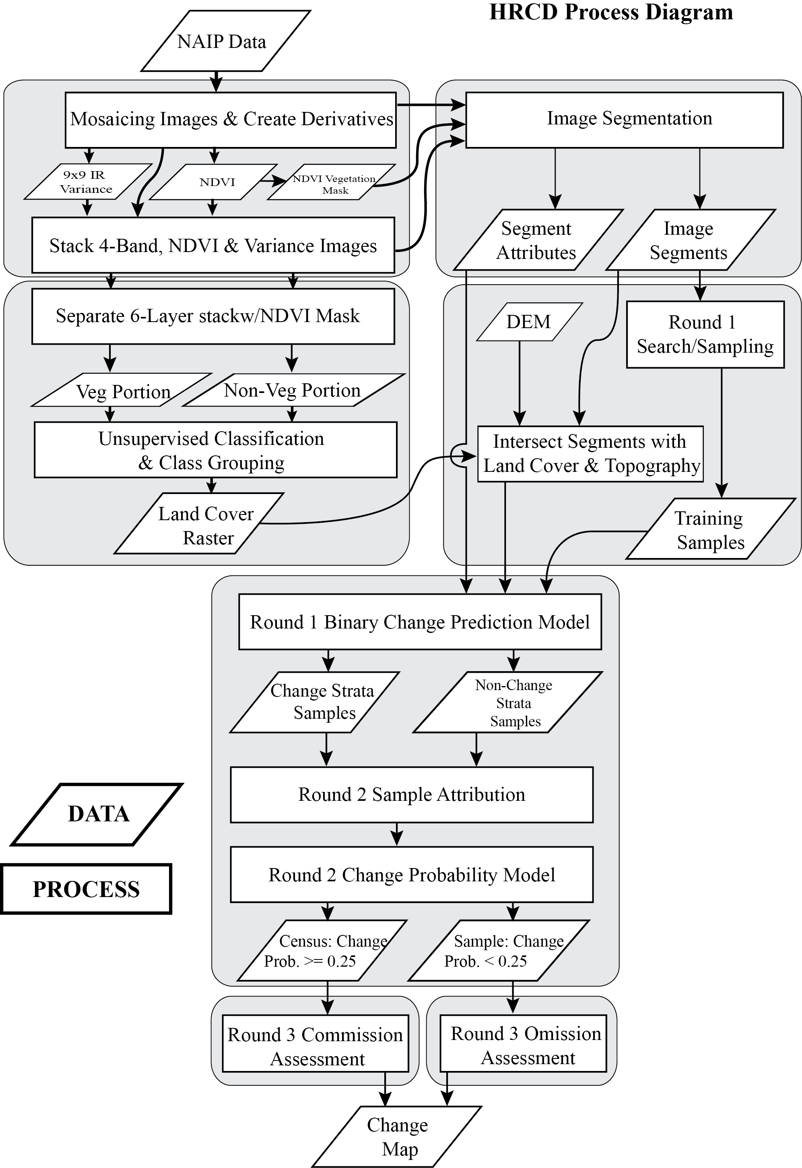

Figure 1: Major process steps and products for HRCD procedure.

The two thematic layers will be generated through unsupervised classification followed by target land-cover attribution. They will include a 9-class land-cover map and a vegetation mask for each 2009, and 2011 image (due to the presence of an infra-red image band). For the 2006 NAIP only a shadow mask will be produced.

Change maps will be produced in addition to estimates of omitted change acreage. Each mapped change area will be reviewed by an analyst before being marked as changed. In each case >50% of the polygon marked as changed will be actual change. Polygons are produced through image segmentation and can sometimes result in aggregations of different adjacent land covers.

The aerial image base for the project will be developed from two sets of imagery:

#### Washington 2006 NAIP Ortho-Imagery Data [18 Inch]

The National Agriculture Imagery Program (NAIP) acquires digital ortho imagery during the agricultural growing seasons in the continental U.S.

2006 NAIP images will be obtained from the Washington State Department of Ecology. The images are provided as 14.027889 Square Kilometer tiles that are cast in a Lambert Conformal Conic projection and NAD83 State Plane Coordinate System (FIPS Zone 4602) in units of US Survey Feet. They are provided as uncompressed TIF image files.

These images have an 18 inch ground sample distance (GSD), which have been generalized to 1 meter for analysis purposes. Ortho-imagery meets Farm Services Agency, National Agricultural Imagery Program standards. Source aerial photography was scanned at 10 microns, ortho rectified, color balanced, and mosaicked using most nadir portions of all images by Washington State Department of Natural Resources (WDNR) and Washington State Department of Transportation.

ERDAS Imagine 2010 software will be used to mosaic the image tiles into a number of WRIA-scale ERDAS® Imagine format (.img) images. Resulting images will be re-projected to match Washington’s state plane projection NAD83 HARN State Plane Washington South FIPS 4602 (Feet) and viewed with a min-max stretch.

#### Washington 2009 and 2011 NAIP Ortho-Imagery Data [1 meter]

2009/11 NAIP images will be obtained from WDNR. The images are provided as tiles, whose format is based on a 3.75' x 3.75' quarter quadrangle with a 300 Meter buffer on all four sides. Source NAIP imagery is formatted to the NAD83 UTM coordinate system for Zone 10 in units of meters, and are provided as uncompressed TIF image files.

These images have a one meter ground sample distance (GSD) with a horizontal accuracy that matches within +/- 5 meters of reference digital ortho quarter quads (DOQQ's) from the National Digital Ortho Program (NDOP) or from the National Agriculture Imagery Program (NAIP).

ERDAS Imagine 2011 software will be used to mosaic the image tiles into a number of WRIA-scale ERDAS® Imagine format (.img) images. Resulting images will be re-projected to match Washington’s state plane projection NAD83 HARN State Plane Washington South FIPS 4602 (Feet) and viewed with a min-max stretch.

The image segmentation step will use both images, the difference image and two thematic layers. The thematic layers will a mask for vegetation/no-vegetation. The image segmentation will be done with eCognition 8 software (Trimble, 2012). The non-vegetation mask is used to constrain the initial large scale segmentation. Successive refinement and aggregation eventually removes very small segments caused by the initial constraint. The segments represent relatively homogenous areas across the two time periods with the intention that change locations are aggregated into separate polygons.

Classification into change and non-change polygons is completed through supervised classification of a training set of segments and subsequent Random Forest predictions performed in R 3 (R Core Team, 2013) for the remaining segments.

Full methods documentation can be found in appendix B.

## B-5 Quality Control

Sample locations for the above procedures are extracted as jpegs from the original imagery data. These jpegs are used for the training analysis. As separate individual image sets they can be provided along with the summary accuracy assessments in order to reproduce the conditions under which the training takes place.

## B-6 Instrument testing

Not applicable.

## B-7 Instrument calibration

Not applicable.

## B-8 Inspection/Acceptance for supplies

Not applicable.

## B-9 Data Acquisition (Nondirect Measurements)

Phase I HRCD analysis uses 2006 and 2009 NAIP imagery acquired from the WDNR. The Phase II analysis will be based on the 2009 NAIP data set and the newly-acquired 2011 NAIP data set. Information on the NAIP program is available at <http://www.fsa.usda.gov/FSA/apfoapp?area=home&subject=prog&topic=nai>.

## B-10 Data Management

The processing of Phase I and Phase II images results in several very large (10-50 gb) files with numerous intermediate steps in processing. All image products will be maintained locally on external USB drives with at least one duplicate of each final product on a second drive. A common folder structure is used to track the numerous steps in the process. The folder structure is captured in a tracking spreadsheet (Appendix B).

# Group C: Assessment/Oversight

## C-1 Assessments and Response Actions

The Principal investigator will assess progress by means of the WRIA Analysis Tracking Spreadsheet, an example of which is shown in Appendix B. This spreadsheet is set up as a folder structure which gets filled in as the individual steps/products are created. In addition, weekly status meetings between spatial analysts and the project manager are envisioned. Problems that arise and causes of project delays will be identified by the team. Appropriate solutions will be determined and implemented in a timely fashion.

## C-2 Reports to Management

All corrective actions will be documented in the project file, along with metadata. The final project report (see Documentation) will describe any and all substantive changes made to the scope of the project and deviations from this QAPP.

# Group D: Data Validation and Usability

## D-1 Data Review, Verification, and Validation

The primary product of this work is an analysis of geo-spatial data as opposed to the collection of geo-spatial data. As such the raw results, locations of change, and their proximity to other data, e.g. marine shorelines, riparian corridors, are based entirely on the definitions of the analysis. The primary step that involves verification is the identification of change locations from the data. A lengthy accuracy assessment step comprises the final 25-30% of the analysis.

## D-2 Verification and Validation Methods

The Principal Investigator will review all project results to determine if they satisfy the stated Quality Objectives (e.g., for completeness, precision, accuracy …).

The accuracy assessment phase includes separate steps for commission and omission errors. Pierce (2011) describes this analysis in more detail. Every polygon predicted to be a change is reviewed by an analyst for commission errors. Changes that are confirmed are coded as permanent if roads or buildings are present or adjacent to the change location.

For omission errors, a random selection of 5,000 polygons is drawn from polygons predicted to be unchanged. Each of the polygons is checked for missed changes. The proportion of the area of missed polygons to the total area of the omission sample is used to estimate total missed change in each WRIA. A full explanation can be found in appendix B.

The data for the accuracy assessment is reviewed as triplets of jpegs, one each from 2006 and 2009, or 2009 and 2011, and the difference image. These triplets are exported from the original imagery for each segment selected for review. A simple classification viewer was developed to rapidly iterate through the triplets and make classification assignments. This set-up greatly increases the speed with which locations can be reviewed and separates the classification review data from the overall data stack. This separation provides a mechanism to exactly reproduce the accuracy assessment data conditions so that the human-subjective classification part can be easily reproduced by a new analyst.

## D-3 Reconciliation with User Requirements

The accuracy assessments described above provide primary means of data reconciliation. The change data, location, and area estimates are a primary data source for numerous other analyses. The key user requirement is high spatial accuracy with low omissions. To that effect we will map urbanization, forestry and natural disturbance events in all 19 Puget Sound WRIAs for the two time periods in question 2006-2009 and 2009-2011. Our goal is to estimate the extent of these events with a minimum of 80% as mapped events.

# References (Including those from Appendix B)

Blaschke, T., Lang, S., & Hay, G. J. (2008). *Object-Based Image Analysis: Spatial Concepts for Knowledge-Driven Remote Sensing Applications (Lecture Notes in Geoinformation and Cartography)* (p. 817). Springer. Retrieved from http://www.amazon.com/Object-Based-Image-Analysis-Knowledge-Driven-Geoinformation/dp/3540770577

Booth, D. B., Hartley, D., & Jackson, R. (2002). Forest Cover, Impervious-Surface Area, and the Mitigation of Stormwater Impacts. *Journal Of The American Water Resources Association*, *38*(3), 835–845. doi:10.1111/j.1752-1688.2002.tb01000.x

Breiman, L. (2001). Random Forests. (R. E. Schapire, Ed.)*Machine Learning*, *45*(1), 5–32. doi:10.1186/1478-7954-9-29

Burnett, C., & Blaschke, T. (2003). A multi-scale segmentation/object relationship modelling methodology for landscape analysis. *Ecological Modelling*, *168*(3), 233–249. doi:10.1016/S0304-3800(03)00139-X

Cadenasso, M. L., Pickett, S. T. a., & Schwarz, K. (2007). Spatial heterogeneity in urban ecosystems: reconceptualizing land cover and a framework for classification. *Frontiers in Ecology and the Environment*, *5*(2), 80–88. doi:10.1890/1540-9295(2007)5[80:SHIUER]2.0.CO;2

Claggett, P. R., Okay, J. a., & Stehman, S. V. (2010). Monitoring Regional Riparian Forest Cover Change Using Stratified Sampling and Multiresolution Imagery. *JAWRA Journal of the American Water Resources Association*, *46*(2), 334–343. doi:10.1111/j.1752-1688.2010.00424.x

Cleve, C., Kelly, M., Kearns, F. R., & Moritz, M. (2008). Classification of the wildland–urban interface: A comparison of pixel- and object-based classifications using high-resolution aerial photography. *Computers, Environment and Urban Systems*, *32*(4), 317–326. doi:10.1016/j.compenvurbsys.2007.10.001

Congalton, R. G., & Green, K. (2008). *Assessing the Accuracy of Remotely Sensed Data: Principles and Practices, Second Edition (Mapping Science)* (p. 183). CRC Press. Retrieved from http://www.amazon.com/Assessing-Accuracy-Remotely-Sensed-Data/dp/1420055127

Cutler, D. R., Edwards, T. C., Beard, K. H., Cutler, A., Hess, K. T., Gibson, J., & Lawler, J. J. (2007). Random forests for classification in ecology. *Ecology*, *88*(11), 2783–92. Retrieved from http://www.ncbi.nlm.nih.gov/pubmed/18051647

Dare, P. (2005). Shadow analysis in high-resolution satellite imagery of urban areas. *Photogrammetric Engineering and Remote Sensing*, *71*(2), 169–177. Retrieved from http://asprs.org/a/publications/pers/2005journal/february/2005_feb_169-177.pdf

Ehlers, M., Gaehler, M., & Janowsky, R. (2006). Automated techniques for environmental monitoring and change analyses for ultra high-resolution remote sensing data. *Photogrammetric Engineering & Remote Sensing*, *7*(July), 835–844. Retrieved from http://asprs.org/a/publications/pers/2006journal/july/2006_jul_835-844.pdf

ESRI (Environmental Systems Resource Institute). (2011). ArcMap. Redlands, California: ESRI.

Goward, S. N., Davis, P. E., Fleming, D., Miller, L., & Townshend, J. R. (2003). Empirical comparison of Landsat 7 and IKONOS multispectral measurements for selected Earth Observation System (EOS) validation sites. *Remote Sensing of Environment*, *88*(1-2), 80–99. doi:10.1016/j.rse.2003.07.009

Haralick, R. M., & Shapiro, L. G. (1985). Image segmentation techniques. *Computer Vision, Graphics, and Image Processing*, *29*(1), 100–132. doi:10.1016/S0734-189X(85)90153-7

Hastie, T., Tibshirani, R., & Friedman, J. (2009). *The Elements of Statistical Learning: Data Mining, Inference, and Prediction, Second Edition (Springer Series in Statistics)* (p. 745). Springer. Retrieved from http://www.amazon.com/The-Elements-Statistical-Learning-Prediction/dp/0387848576

Hay, G. J., Castilla, G., Wulder, M. a., & Ruiz, J. R. (2005). An automated object-based approach for the multiscale image segmentation of forest scenes. *International Journal of Applied Earth Observation and Geoinformation*, *7*(4), 339–359. doi:10.1016/j.jag.2005.06.005

Huth, J., Kuenzer, C., Wehrmann, T., Gebhardt, S., Tuan, V. Q., & Dech, S. (2012). Land Cover and Land Use Classification with TWOPAC: towards Automated Processing for Pixel- and Object-Based Image Classification. *Remote Sensing*, *4*(12), 2530–2553. doi:10.3390/rs4092530

Liaw, A., & Wiener, M. (2002). Classification and Regression by randomForest. *R News*, *2*(3), 18–22.

Liknes, G., Perry, C., & Meneguzzo, D. (2010). Assessing tree cover in agricultural landscapes using high-resolution aerial imagery. *Journal of Terrestrial Observation*, *2*(1). Retrieved from http://docs.lib.purdue.edu/cgi/viewcontent.cgi?article=1065&context=jto

Linke, J., & McDermid, G. J. (2011). A Conceptual Model for Multi-Temporal Landscape Monitoring in an Object-Based Environment. *IEEE Journal of Selected Topics in Applied Earth Observations and Remote Sensing*, *4*(2), 265–271. doi:10.1109/JSTARS.2010.2045881

Lu, D., Hetrick, S., Moran, E., & Li, G. (2010). Detection of urban expansion in an urban-rural landscape with multitemporal QuickBird images. *Journal of Applied Remote Sensing*, 1–22. doi:10.1117/1.3501124.Detection

Lu, D., Mausel, P., Brondízio, E., & Moran, E. (2004). Change detection techniques. *International Journal of Remote Sensing*, *25*(12), 2365–2401. doi:10.1080/0143116031000139863

McBride, M., & Booth, D. B. (2005). Urban Impacts on Physical Stream Condition: Effects of Spatial Scale, Connectivity, and Longitudinal Trends. *Journal Of The American Water Resources Association*, *41*(3), 565–580. doi:10.1111/j.1752-1688.2005.tb03755.x

Moskal, L. M., Styers, D. M., & Halabisky, M. (2011). Monitoring Urban Tree Cover Using Object-Based Image Analysis and Public Domain Remotely Sensed Data. *Remote Sensing*, *3*(12), 2243–2262. doi:10.3390/rs3102243

O’Neil-Dunne, J. P. M., MacFaden, S. W., Royar, A. R., & Pelletier, K. C. (2013). An object-based system for LiDAR data fusion and feature extraction. *Geocarto International*, *28*(3), 227–242. doi:10.1080/10106049.2012.689015

Olofsson, P., Foody, G. M., Stehman, S. V., & Woodcock, C. E. (2013). Making better use of accuracy data in land change studies: Estimating accuracy and area and quantifying uncertainty using stratified estimation. *Remote Sensing of Environment*, *129*(null), 122–131. doi:10.1016/j.rse.2012.10.031

Pontius, R G, Shusas, E., & McEachern, M. (2004). Detecting important categorical land changes while accounting for persistence. *Agriculture, Ecosystems and Environment*, *101*(2-3), 251–268.

Pontius, Robert Gilmore, Boersma, W., Castella, J.-C., Clarke, K., Nijs, T., Dietzel, C., … Verburg, P. H. (2007). Comparing the input, output, and validation maps for several models of land change. *The Annals of Regional Science*, *42*(1), 11–37. doi:10.1007/s00168-007-0138-2

R Core Team. (2013). R: A Language and Environment for Statistical Computing. Vienna, Austria: R Foundation for Statistical Computing. Retrieved from http://www.r-project.org/

Randhir, T. O., & Hawes, A. G. (2009). Watershed land use and aquatic ecosystem response: Ecohydrologic approach to conservation policy. *Journal of Hydrology*, *364*(1-2), 182–199. doi:10.1016/j.jhydrol.2008.10.017

Rodriguez-Galiano, V. F., Ghimire, B., Rogan, J., Chica-Olmo, M., & Rigol-Sanchez, J. P. (2012). An assessment of the effectiveness of a random forest classifier for land-cover classification. *ISPRS Journal of Photogrammetry and Remote Sensing*, *67*, 93–104. doi:10.1016/j.isprsjprs.2011.11.002

Snyder, M., Goetz, S., & Wright, R. (2005). Stream Health Rankings Predicted by Satellite Derived Land Cover Metrics. *JAWRA Journal of the American Water Resources Association*, *June*, 659–677. Retrieved from http://onlinelibrary.wiley.com/doi/10.1111/j.1752-1688.2005.tb03762.x/abstract

Timm, B., & McGarigal, K. (2012). Fine-scale remotely-sensed cover mapping of coastal dune and salt marsh ecosystems at Cape Cod National Seashore using Random Forests. *Remote Sensing of Environment*, *127*, 106–117. Retrieved from http://www.sciencedirect.com/science/article/pii/S0034425712003525

Trimble. (2012). eCognition Developer 8.7.2. Munchen, Germany: Trimble Germany GmbH.

Ware, C. (2008). *Visual Thinking: for Design (Morgan Kaufmann Series in Interactive Technologies)* (p. 256). Morgan Kaufmann. Retrieved from http://www.amazon.com/Visual-Thinking-Kaufmann-Interactive-Technologies/dp/0123708966

Zhou, W., Troy, A., & Grove, M. (2008). Object-based land cover classification and change analysis in the Baltimore metropolitan area using multitemporal high resolution remote sensing data. *Sensors*, *8*, 1613–1636. Retrieved from http://www.mdpi.com/1424-8220/8/3/1613

Zimmerman, P. L., Housman, I. W., Perry, C. H., Chastain, R. a., Webb, J. B., & Finco, M. V. (2013). An accuracy assessment of forest disturbance mapping in the western Great Lakes. *Remote Sensing of Environment*, *128*, 176–185. doi:10.1016/j.rse.2012.09.017

**Appendices**

## Appendix A – Abbreviations, Common Acronyms, and Glossary

DOQQ: Digital Ortho Quarter-Quads

ERDAS: Earth Resources Data Analysis System

ESRI: Environmental Systems Resources Institute

FIPS: Federal Information Processing Standards  
GIS: Geographic Information Systems

GSD: Ground Sample Distance

HRCD: High Resolution Change Detection

NAD: North American Datum

NAIP: National Agriculture Imagery Program

QA: Quality Assurance

QAPP: Quality Assurance Program Plan

TIFF: Tagged image file format

WDFW: Washington Dept. of Fish & WIldlife

WDNR: Washington Dept. of natural Resources

WRIA: Water Resource Inventory Area

## Appendix B Methods Excerpt from manuscript in preparation

## 2. Methods

### 2.1 Mapping “change events”

The overall modeling procedure is mapped out as a flow chart in figure 1. Shaded sections correspond to procedures carried out in the subsections described below. In its simplest form, this method uses sampling and statistical modeling to predict which spatial units (polygons) in the landscape looked like what had been coded as change events in the training data. Those units with some minimum predicted probability of change were then photo interpreted, observed by an analyst, to make the final decision as to whether or not those polygons had actually changed. For polygons below the minimum probability threshold, a large sample was taken and observed similarly to the high probability census polygons. This method harnesses the extraordinarily sophisticated pattern recognition abilities of the human brain (Ware, 2008) but also injects a subjective component into mapping change. Because the intent of this study was to quantify specific types of change events, a rule set was developed for what would be labeled change.

**Figure 1**. Flowchart of overall change mapping methodology. Bolded numbers indicate the methods section that describes the steps within the associated box.

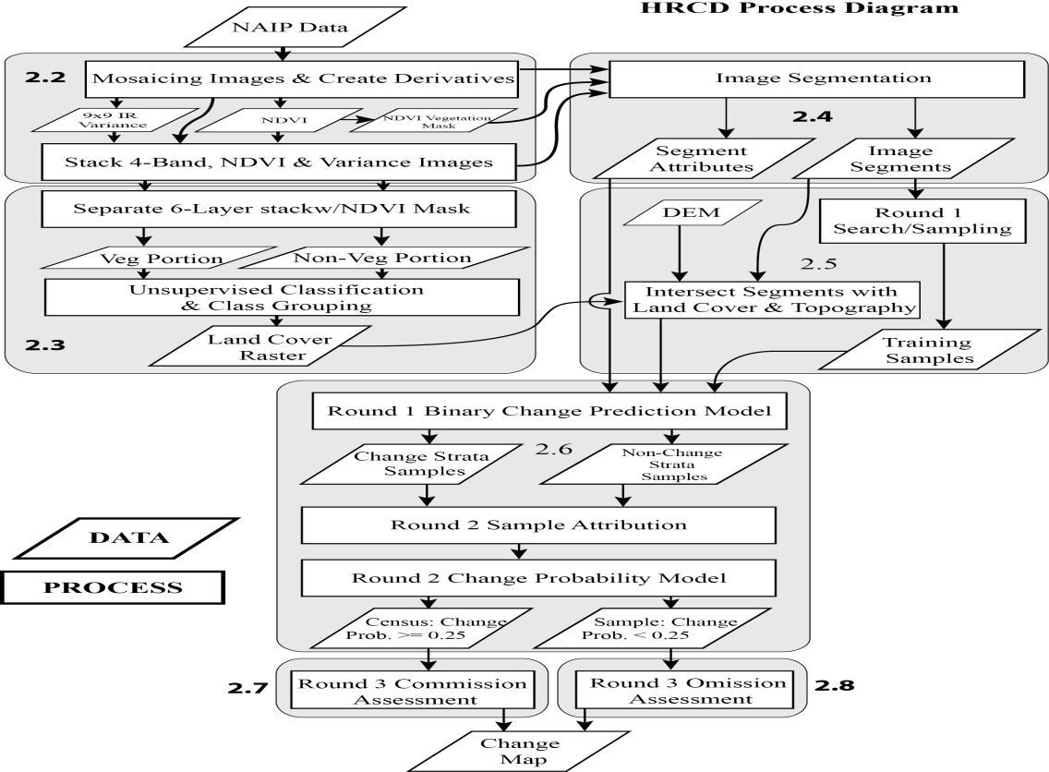

Changes of interest were specifically focused on loss of ecological function, where the primary functions captured are changes in hydrologic resistance and loss of natural or semi-natural habitat (McBride & Booth, 2005; Randhir & Hawes, 2009). This type of change is the result of three major drivers or mechanisms: 1) development, 2) forestry, and 3) natural change that represent permanent anthropogenic change, transient anthropogenic change, and non-anthropogenic change. Changes mapped as development were typically those showing new structures, an appearance of site preparation for building or were in close proximity to urban development. Changes events were mapped as natural where they appeared to be the result of stream erosion, landslides or storm/fire damage. Tree clearing that showed no signs of site preparation or exhibited some obvious vegetative regrowth was labeled as forestry. This class is a catchall for areas of obvious tree clearing which may or may not result in regrowth and are sometimes referred to as forestry/unknown. As future maps are produced these determinations can be revisited and updated as new information is gathered.

The statistical modeling phase only predicts the binary response of change/no-change. Thus, during the training phase, detailed below, polygons are simply labeled as change/no-change using the above criteria. As such the model provides a probability of change for each polygon. In the final accuracy assessment step, the analyst makes the determination as to whether a polygon is mapped as change or not. This also provides an opportunity to note one of the three mechanisms of change, but this assessment is not modeled, it is assessed by the observer at the time of verification.

While change rates are one of numerous potential analytical results of this analysis, the location and characteristics of individual change events are the basic output. Therefore the change definition and locational precision are paramount to supporting future assessments when combined with other data. As a natural resource issue, managers are concerned with mapping urbanization events, activities with long-term hydrologic implications and the reduction and fragmentation of natural and semi-natural areas. Ground permeability is a key factor in assessing the maintenance of natural function (Booth, Hartley, & Jackson, 2002). For that reason the loss of vegetative cover or the conversion to impermeable surfaces are useful indicators of a landscape’s trajectory with regard to ecosystem services (Snyder, Goetz, & Wright, 2005). From a remote sensing standpoint, loss of vegetative cover can range from cutting down old growth forests to clearing invasive shrubs to harvesting an annual crop. From an analyst’s perspective, a decision must be made as to which of these changes is important to document. These changes are obviously not all equal nor do their effects necessarily play out over similar time scales. An old-growth or even regrown forest can take decades to centuries to regain its initial ecological function. Crops will return the following year (with slightly altered soil conditions) and invasive shrubs may return within a few years. The goal here in mapping the loss of vegetative cover is to capture the former change, the loss of trees or mature shrubs. Crop harvest and simple mechanical clearing are removed from mapped changes where detectable. Secondarily the conversion from vegetation or bare ground to impervious surface is an abrupt, rarely reversed change (R G Pontius, Shusas, & McEachern, 2004) and is always mapped. The quality of altered habitats is not assessed here, but is left to further investigation during studies utilizing the outputs of this analysis along with known or mapped distributions of specific ecological systems or species distributions.

### 2.2 Image data processing

High resolution aerial imagery (1 m) from the National Agriculture Imagery Program (NAIP) was used as the primary data source. These data are being widely explored for their utility in providing land-cover/land-use and change detection information (Claggett, Okay, & Stehman, 2010; Liknes, Perry, & Meneguzzo, 2010; Moskal, Styers, & Halabisky, 2011). Washington has complete state NAIP data for 2006, 2009 and 2011. The state of Washington is split into 62 Water Resource Inventory Areas (WRIAs) often using major river watershed boundaries that range in size from about 50,000 ha to over 700,000 ha. Nineteen WRIAs occur around Puget Sound and to date 15 have been mapped for the 2006-2009 time interval using an evolving set of the methods discussed here.

Georectified image data were acquired from the WA Dept. of Natural Resources in 10km x 10km tiles. Individual WRIAs were used as areas of analysis and whole WRIA mosaics were created for the two time periods. The 2006 data had three visible spectral bands and was delivered at an 18 inch resolution. The 2006 data was rescaled in Erdas Imagine to one meter to match the resolution of the 2009 data. Additionally, the 2009 data included a fourth band covering the near infra-red spectrum. A change image was generated by subtracting the 2006 three band data from the three visible bands of the 2009 data.

For the 2009 data the Normalized Difference Vegetation Index (NDVI) was calculated using the red and infra-red bands according to (Goward, Davis, Fleming, Miller, & Townshend, 2003):

|  |  |
| --- | --- |
|  | (1) |

This NDVI layer provides a tool for separating areas with and without vegetation and also provides a saturating spectral measure of vegetative abundance. A 9x9 pixel simple-variance layer was calculated for the infra-red band (Ehlers, Gaehler, & Janowsky, 2006). This layer was intended to help differentiate dark homogenous crops from similarly dark forested areas when aggregated as segments. These two layers were added to the 4-band 2009 image to create a six-layer data stack for 2009.

### 2.3 Land Cover modeling

This study focused on WRIA 10, one of the 19 Puget Sound watersheds. WRIA 10 encompasses the Puyallup and White river basins and ranges from Tacoma at sea level to the top of Mount Rainier (Figure 2). It covers 272,932 ha with an elevation range from 0 to 4,394 m. National Parks and forests make up just over 40% of the total area, occupying the upper range of elevations.

Unsupervised classification was used to convert the pixel data into a land cover map (Hastie, Tibshirani, & Friedman, 2009). The full procedure differed for the 2006 and 2009 images due to the difference in available bands. The 2006 land cover image was derived from the three band image for 2006 and the 2009 land cover was derived from the six band image created above from the 4-band 2009 image and the two derived layers, NDVI and the 9x9-IR variance. For 2006, a 50 class image was created in Erdas Imagine and grouped into meaningful land cover classes.

**Figure 2**. The Puyallup-White watershed is one of 19 Water Resource Inventory Areas (WRIA) making up the Puget Sound region of Washington St. WRIA 10, the location of this study, covers 272,932 ha and rises from the city of Tacoma at sea level up to the top of Mt. Rainier at 4,394 m. For reference in later analyses, elevation contours are shown at 300 m (blue) and 1500 m (purple).

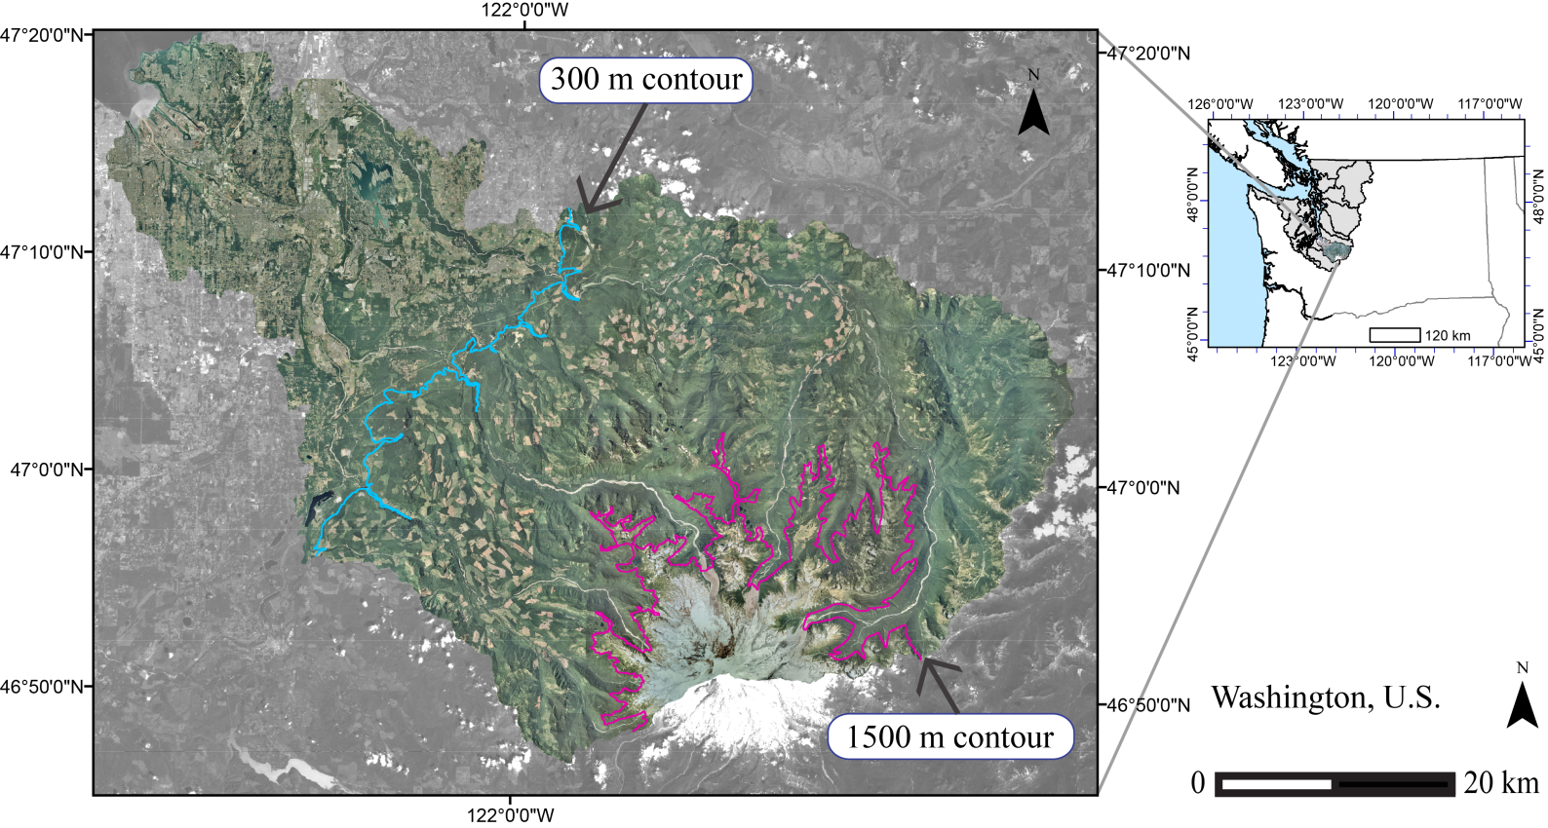The 2009 analysis started with a vegetation/no-vegetation mask created from the NDVI image (Lu et al., 2010). The mask was used to split the six band image like a spatial color separation. A non-vegetation image was generated corresponding to places in the mask image with a zero value of NDVI and a vegetation image was generated with all remaining pixels. These two groups were separately subjected to unsupervised classification. Twenty-five classes were generated for the non-vegetation image and 50 for the vegetation image. These two resulting layers were grouped separately and then added back together to create a 2009 land cover classification. The non-vegetation image was aggregated into the following classes: 1) shadow/water, 2) built/gray, 3) bare ground and 4) uncertain. The vegetation fraction was classified as 5) herb/grass, 6) tree and 7) shrub/indeterminate. Since the land cover classification was only used to inform the change model, a shadow class was used to recognize the inability to discern actual classes from limited reflected energy (Dare, 2005). The shrub class was considered a semi-indeterminate class as the difference between dark grass, shrubs and brightly lit trees can be very hard to distinguish(Cadenasso, Pickett, & Schwarz, 2007; Cleve, Kelly, Kearns, & Moritz, 2008; Zhou, Troy, & Grove, 2008).

The veg/non-veg mask was used for the segmentation analysis described below. The land-cover layers were not used to create segments but were used to attribute the segments below for the final statistical change model.

### 2.4 Segment generation

Segmentation is a process that takes a raster of pixels and groups them into relatively homogenous regions (Blaschke et al., 2008; Haralick & Shapiro, 1985). With high resolution imagery, single pixels represent only parts of individual features such as trees, houses or fields. This is the opposite problem from medium resolution imagery which often smooth’s over multiple features in urban settings. The segmentation process was performed using eCognition 8.7 and the eCognition server (Trimble, 2012). The process uses spatial variability in one or more spectral layers to delineate areas of relative homogeneity. Segmentation starts with random seed pixels, then grows polygons by accretion, selecting the next pixel that when added minimizes some homogeneity criteria. The size of the resulting polygons is influenced by a variability parameter and the complexity by a relative weighting scheme which weights image growth on a continuum between minimizing spectral-variability and minimizing shape complexity. The final product is a complete polygon map of the original image data. This is a vital step for dealing with the high pixel-to-pixel variability in high resolution data (Burnett & Blaschke, 2003; Hay, Castilla, Wulder, & Ruiz, 2005; O’Neil-Dunne, MacFaden, Royar, & Pelletier, 2013).

There were 13 image layers involved in the segmentation process, including three 2006 bands, the six-layer stack from 2009 and the three difference bands. Additionally the veg/non-veg mask was used as a thematic layer. The segmentation process proceeded from large landscape features, constrained to the veg/non-veg layer, down to smaller pieces and then coalesced to a final analysis set. For change detection, the segmentation was performed simultaneously across time periods. An alternative is to perform the segmentation separately for each time period and look for differences. By performing the segmentation simultaneously across the change interval the analysis was able to more specifically focus on delineating changed areas as separate polygons and minimize the production of sliver polygons due to random image differences (Linke & McDermid, 2011). The polygons were exported as a simple feature with key attributes (Table 1).

**Table 1.** Predictor variables for the Random Forests model. Predictors 1-41 were generated directly by eCognition (Trimble, 2012). Land cover proportions were derived from extracting per segment information from the 2009 Land Cover model. Elevation was derived from sampling a 10-m DEM with the segments. Predictors 50-59 were calculated from an exported data set of linked sub objects generated as part of the segmentation process.

|  |  |  |
| --- | --- | --- |
| **#** | **Polygon Attributes** | **Type/Units** |
| 1-3 | 2006 Bands: Red, Green, Blue | Polygon Mean |
| 4-6 | 2009 Bands: Red, Green, Blue | Polygon Mean |
| 7 | 2009 Band 4: Infrared | Polygon Mean |
| 8 | 2009 Derived: NDVI | Polygon Mean |
| 9-11 | 2009-2006 Difference: Red, Green, Blue | Polygon Mean |
| 12-22 | Same as 1-11 | Polygon St. Deviation |
| 23 | Contrast neighbor 2006 Red | Unitless |
| 24 | Contrast neighbor 2009 Red | Unitless |
| 25-26 | 2006, 2009 Average Visible Brightness | Polygon Mean |
| 27 | Brightness Difference | Polygon Mean |
| 28-29 | 2006, 2009 Average Visible Saturation (gray level) | Polygon Mean |
| 30 | Difference in Saturation | Polygon Mean |
| 31 | Rectangular Fit | Unitless |
| 32 | Edge to Area Ratio | Unitless |
| 33 | Width of Main Branch | Meters |
| 34-35 | UTM Longitude, Latitude | Meters |
| 36-37 | 2006, 2009 GLCM Homogeneity Red Band | Polygon Texture |
| 38 | GLCM Homogeneity Red Difference | Polygon Texture |
| 39-40 | 2006, 2009 GLCM Entropy Red Band | Polygon Texture |
| 41 | GLCM Entropy Red Diff | Polygon Texture |
| 42-48 | 2009 Land Cover Proportions | Classification |
| 49 | Elevation | Polygon Mean |
| 50 | Count of SubObjects | SubObjects Statistic |
| 51 | Saturation Variance 06 | SubObjects Statistic |
| 52 | Saturation Variance 09 | SubObjects Statistic |
| 53 | Saturation Variance Difference | SubObjects Statistic |
| 54 | Brightness Variance 06 | SubObjects Statistic |
| 55 | Brightness Variance 09 | SubObjects Statistic |
| 56 | Brightness Variance Difference | SubObjects Statistic |
| 57 | Edge-Area ratio Variance | SubObjects Statistic |
| 58 | GLCM 2006 Red Variance | SubObjects Statistic |
| 59 | GLCM 2009 Red Variance | SubObjects Statistic |

The exported segments were merged into a file geodatabase and augmented with total area and several placeholder variables to annotate which polygons were used for training and predictions along with other model output. The segments were used for the following procedures as the primary unit of analysis for both the training data and the statistical modeling. Final predictions and mapping were at the segment scale. Due to the generation by homogeneity criteria, segments ranged in size from less than a 1/10 ha in heterogeneous areas up to around 50 ha in places like continuous forested zones and large water bodies.

### 2.5 Round 1 training data and the AAViewer

Training data were generated from a simple search for changed polygons and change-like polygons plus a review of ~500 randomly selected polygons. In general the randomly selected samples were non-change polygons. Some change-like polygons returned from the simple search represented false positives (figure 3f). These were polygon pairs which had similar spectral characteristics to change polygons but which had not changed by visual inspection. These were primarily places in dark shadows in time period one and with bright illumination in the second image. These could also include polygons such as agricultural fields that were green in 2006 and bare in 2009. The purpose for Round 1 was to generate data to create a model that split the full polygon set into strata as either more similar to the changed polygons in the Round 1 training set or more similar to the non-changed polygons. While scanning for changes, specific examples of forest-to-cleared, forest-to-built and cleared-to-built were included in the training data (figure 3). The purpose of the first round was to enable a random sampling from the generated strata. The predictions needed to include obvious errors so that a larger training sample could be generated that included both real and false changes which would be correctly attributed in Round 2 to drive the final model.

**Figure 3**. Examples of change types included in Round 1 and Round 2 training data. A-D are self-explanatory. **(e.)** Natural changes most commonly are stream course changes, land-slides and fires. (f.) False changes are due to events like tree lean and shifting shadow patterns.

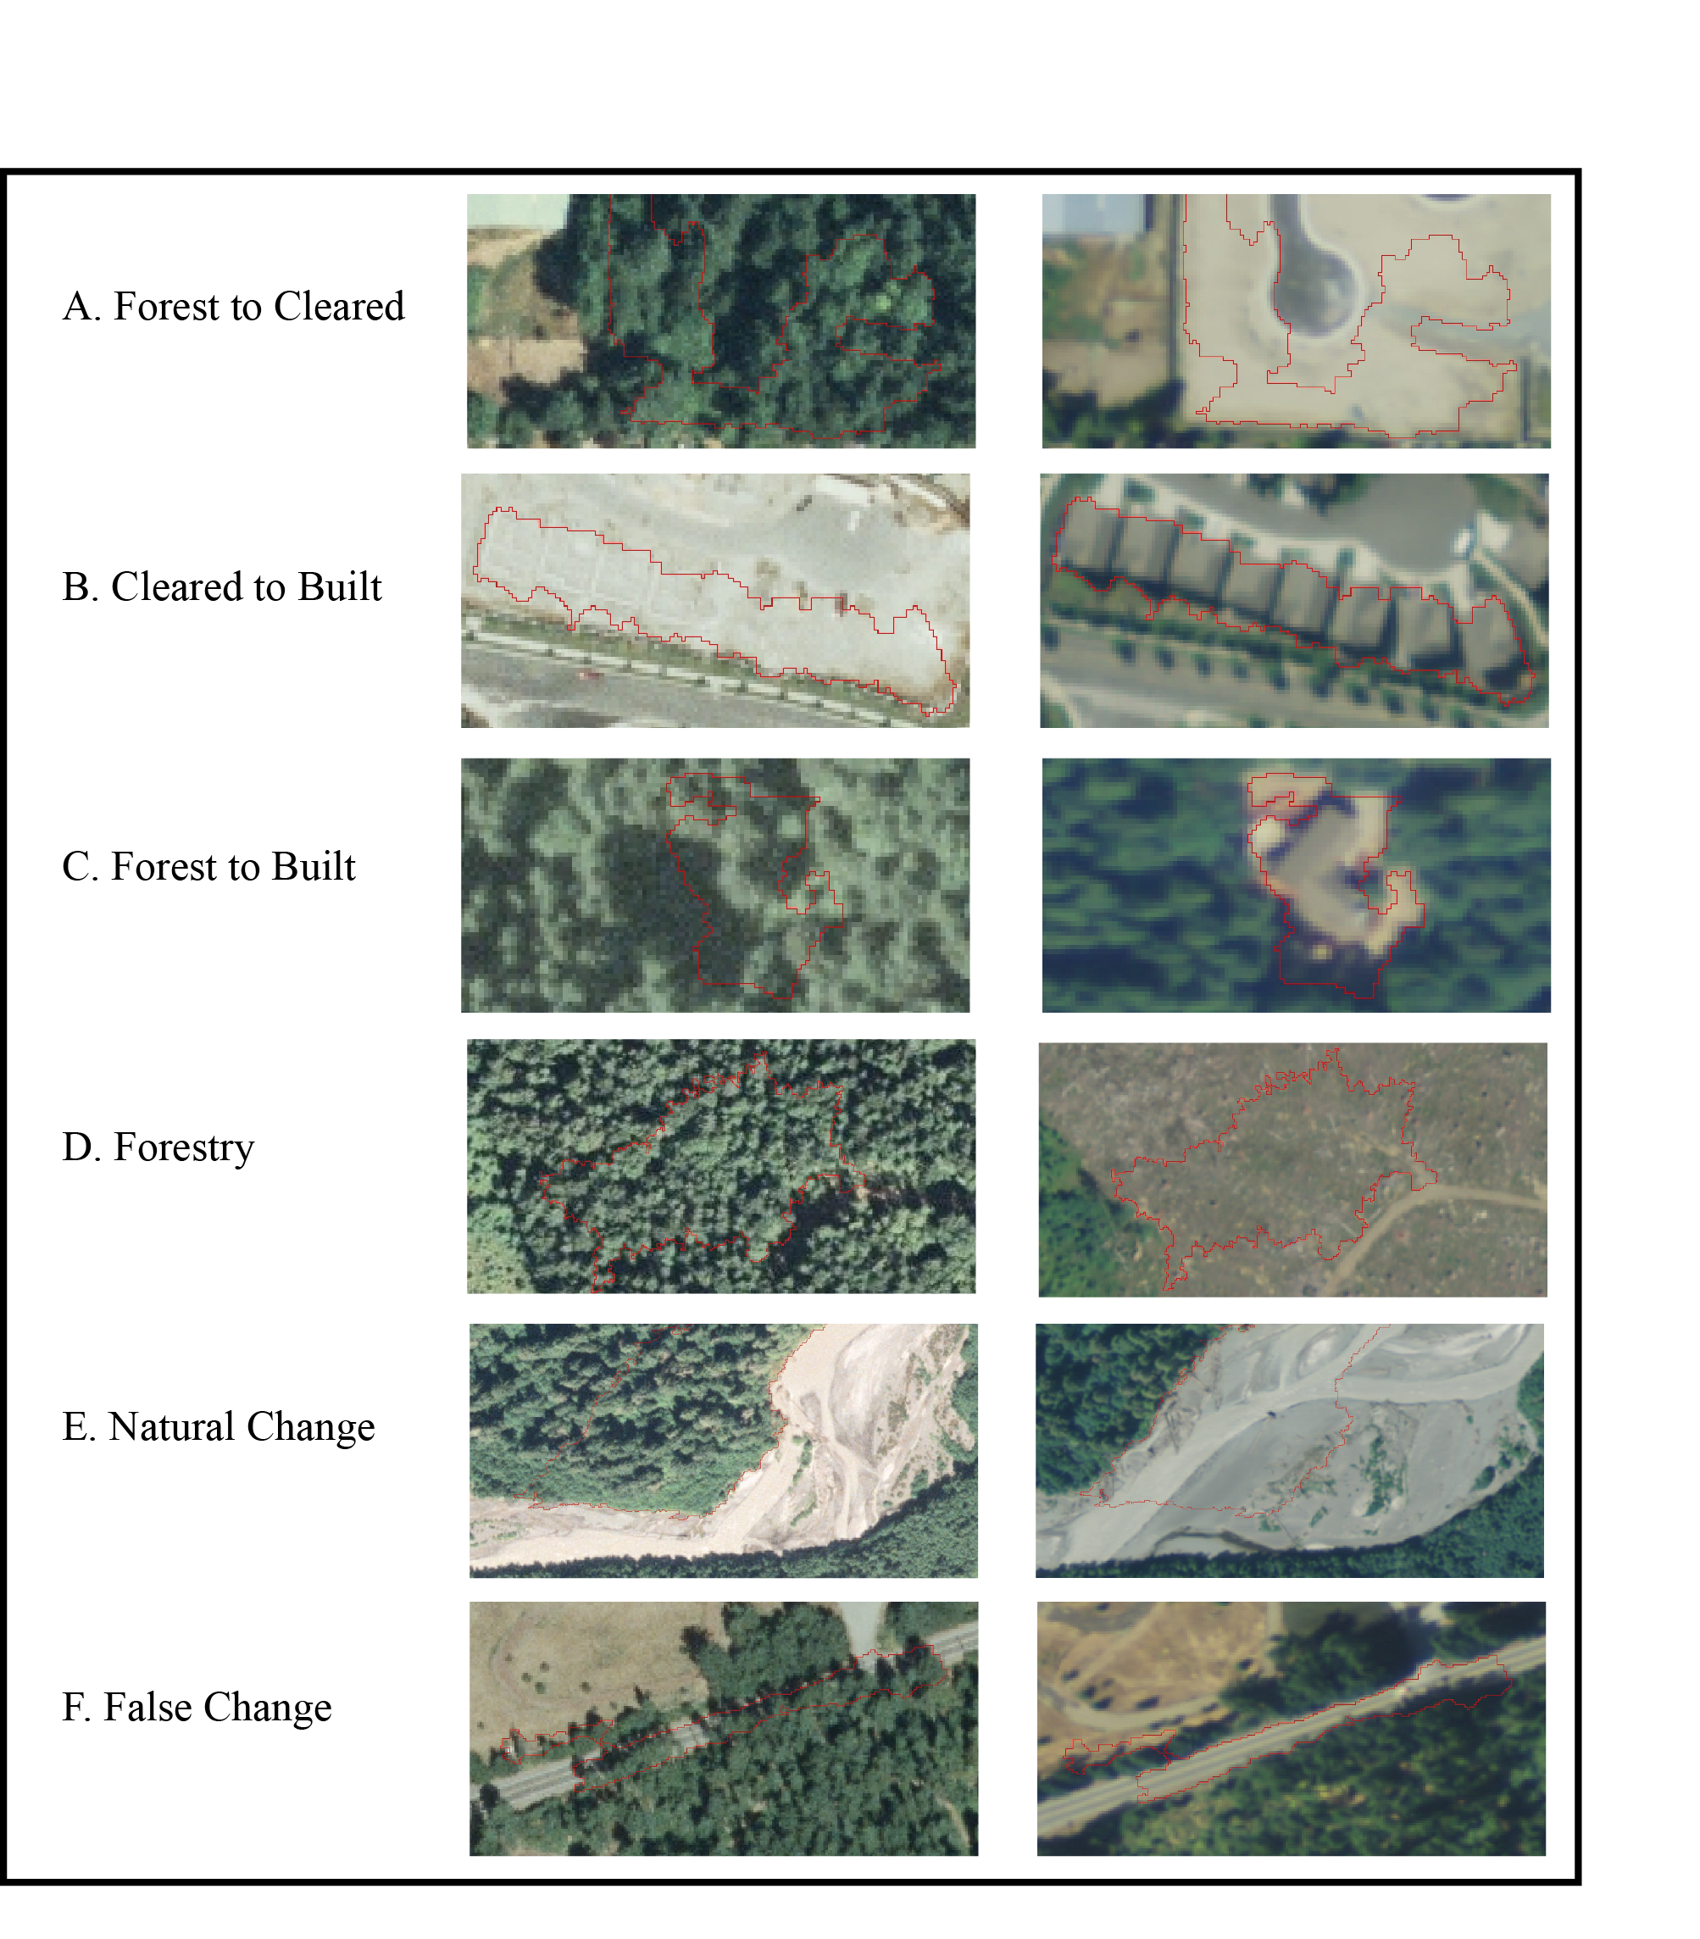

The predictor variables were those derived from eCognition and ancillary information derived from the land-cover modeling and topographic information (Table 1). The polygons were intersected with the 2009 land-cover layer to derive proportions in each cover class for each polygon. The mean elevation for each polygon was also extracted from a 10m DEM. The 2006 land cover data was not utilized due to excessive salt and pepper class mixing. Derived attributes were added to the segment attributes to complete the model predictor data set.

The task of reviewing candidate polygons to be used as training data can be one of the longest manual labor requirements of a change detection project (Huth et al., 2012) so an accuracy assessment system was developed that consisted of two programs designed to facilitate rapid review of polygons or polygon pairs for classification or attribution. The purpose of the accuracy assessment system was to extract as much of the processing time involved with image pair review into an automated step which prepares for an efficient attribution step. The first program, AAClipGenerator, was written in C# and ArcObjects with ArcGIS 10.0 (ESRI (Environmental Systems Resource Institute), 2011) and is dependent upon an ArcGIS mxd file. The mxd contains the polygons of interest for review and the image layers to be compared. AAClipGenerator creates medium sized jpegs for each image representing a single polygon and its surrounding landscape. The scaling is such that the polygon of interest takes up about the middle third of the image. One jpeg is generated for each image layer with the outline of the polygon of interest such that three jpegs are created for each polygon. In this project the image layers were the before image (2006), the visible bands from the after image (2009) and the difference image.

The second program, AAViewer, included a simple user interface designed to minimize key strokes so as to maximize the amount of analyst time spent deciding on a classification and minimize the amount of time waiting for images to load, scrolling around multiple tables and inputting data into clicked fields. The program takes the generated image triplets and an associated data structure, both from AAClipGenerator, and provides a simultaneous view of the images and a data entry pane for attributing them (Figure 4). Using this system an analyst can routinely review and attribute 250-300 polygon triplets an hour. An additional benefit of this system is the ability to reproduce the decision environment for the analyst portion of the project. Since the images and viewer are self-contained, they can be easily passed to a second observer to repeat the analysis and archived with the project to allow future review of the decisions made under identical conditions regarding image scale and orientation. The “commission eliminating” methods below were made feasible solely due to the efficiency gained by this set of programs.

**Figure 4**. AAViewer. The AAViewer program displays three images and an attribution pane for rapidly classifying target polygons. In the figure the upper left image is from 2006, the upper right image is from 2009 and the lower right image is the band-wise difference image. The ChangeClass box stays selected during review and movement between image sets is done with the “W” and “S” keys. The classification procedure requires 2 keystrokes, “S” to advance image sets and 1-9 to denote the change type.

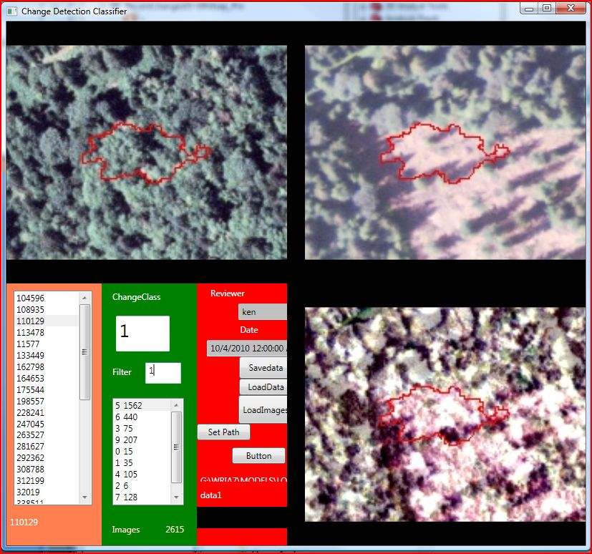

### 2.6 Statistical predictions with Random Forests

Predictions were made from the classified training polygons using the Random Forests (RF) algorithm (Breiman, 2001; Cutler et al., 2007; Hastie et al., 2009; Timm & McGarigal, 2012) implemented with the randomForest package in the R statistical environment (Liaw & Wiener, 2002; R Core Team, 2013). Random Forests is a machine learning algorithm derived from Classification and Regression Trees (CART). CART is a recursive partitioning algorithm that searches a parameter space for a variable value that splits a data set into two leaves with the minimum possible classification error. It continues to split the leaves of the tree until some stopping rule such as “terminal leaf node variance dropping below some maximum value” is reached. Random Forests performs multiple iterations of a CART-style algorithm. For each tree it subsamples both the data and the predictor variable set. This analysis used a binary change/no-change response with 2500 trees sampling 7 variables for each split. However it has been shown that the quantity of variables at each split has little effect on the final outcome once the error rate has stabilized (Rodriguez-Galiano, Ghimire, Rogan, Chica-Olmo, & Rigol-Sanchez, 2012). The model splits the full dataset into changed and non-changed strata from which 2500 random polygons were sampled from each to create the Round 2 model response data. The relative proportion of change polygons, including false change predictions was generally low compared to the non-change portion. These strata were created to ensure an adequate sample of change polygons. These were classified correctly as change/no-change and reviewed for the final model using the AAViewer developed for this project.

Once the 5,000 total samples are reviewed, they are used to create the final Round 2 model. The final prediction for any single polygon was the result of applying the 2500 derived trees to that polygon’s data values. The probability of change was the proportion of model runs that predicted the polygon of interest to have changed. From a classification standpoint, that means a change polygon is any polygon with greater than 1250 trees resulting in a classification of changed or more simply a fraction of change predictions ≥ 0.5.

Predictions from the final model were used to assess the confusion matrix for the modeling procedure. This is sometimes the end product of a classification or change detection project. The final summary output for a RF model run displays the confusion matrix for the last generated tree. This is an assessment of the classification accuracy of the single final tree. To assess the model’s overall ability to discriminate amongst the input data, the model data was run through the full prediction procedure to assess the most probable class for each training polygon after being evaluated by the full “Forest” of prediction trees.

In addition to predicting a class for each polygon, RF also produces a probability of a class based on the votes coming from the individual tree models. For a binary change/no-change response, the simple prediction criteria is any polygon with a proportion of votes >0.5 for the change category. Interpreting RF results can be difficult if the analytical goal is to come up with a mechanistic model for change. The probability of change is a summary statistic calculated over the “Forest” of trees. Each individual tree has a specific deterministic decision tree, but the whole model run integrates over many stochastic trials. Relative importance is attributed to different variables depending on their cumulative contribution over the individual model runs.

### 2.7 AA Procedures –Eliminating Commission

Commission errors are the result of falsely declaring a polygon to be a member of some class. In a multi-class thematic map, every error is a commission error for one class and an omission error for another. In change detection, change is initially the only variable so commission and omission really only have one definition. Commission errors, erroneous inclusions, would be locations mapped as change which did not change during the time-period of observation. Omission errors are the opposite, i.e., locations that changed that were not mapped as change. The RF statistical model provides a designation for each polygon in the study area as either changed or non-changed. The trivial method of eliminating either kind of error is to declare all polygons the same class. Since few locations change, declaring all polygons to have not changed gives a 0% commission error and a 100% omission error while maintaining overall prediction accuracy probably greater than 98% (assuming a short time interval of 1 to a few years). Statistical models are designed to minimize overall error so with two classes, the minimum error would result from assigning the most likely class to each unobserved polygon. This partitions the commission and omission errors into two different fractions. All the commission errors reside with the polygons labeled as change and all the omission errors reside with the polygons labeled as no change. Therefore, to eliminate commission errors, an analyst needs to “check the computer’s work.”

The goal of this analysis was to eliminate as much error as possible with minimal effort, i.e. maximizing the efficiency of the change detection. Since a target polygon must be observed to validate its thematic accuracy, the model was set up to capture as much error as possible in a relatively small area. With change detection, the number of polygons labeled as change is generally much smaller than those labeled as no-change, so the task of eliminating commission error is much smaller than trying to eliminate omission error. The AAViewer was used to review predicted polygons. Assuming half the error is commission error, reviewing all commission polygons should eliminate half of the model error while only reviewing a small portion of the study area (usually <5%).

This is where the procedure becomes a hybrid method of regular predictive statistical modeling and analyst driven photo interpretation. The statistical modeling phase is used to focus the analyst’s effort on those areas most likely to exhibit the target change events. In this way, the predicted change areas are interpreted by an analyst and all mapped change polygons are effectively derived from photo interpretation (Claggett et al., 2010; Zimmerman et al., 2013).

Also, the RF procedure provided a probability of change for each polygon. From the simple classification standpoint, the area of predicted change was made up of those polygons which were most likely change, i.e. those with a probability of change greater than 0.5. If the acceptance threshold for classifying change is lowered, more of the overall error will be pushed into the smaller change fraction. For example if the acceptance threshold is lowered from 0.5 to 0.4 the number of polygons that must be reviewed increases but now ~60% of the error is eliminated. Effectively the overall project error rate has been lowered by 10% by reviewing the extra polygons. As the criteria are decreased the additional effort to eliminate error rises exponentially. Therefore some optimal acceptance criteria should exist beyond which the additional effort is not worth the increase in accuracy. At this point the balancing of the criteria is purely subjective and should be informed by the research question. Ideally one would be able to assign a value to mapping each individual change event and compare it to the cost of an analyst’s time to find that event and create a stopping rule when they are equal. At high change probabilities, an analyst may find every reviewed polygon is a change. At low probability frequencies an analyst may need to review 10-20 polygons to find the next change event. As such the cost to find additional change continues to increase as polygons with smaller change probabilities are reviewed.

### 2.8 AA Procedures- Estimating Omission

While pushing as much error into the commission fraction as possible, there will remain a small number of changes which, for whatever reason, conformed poorly to the samples observed or which are simply computationally indistinguishable with the suite of predictor variables from locations that did not change. For the remaining polygons, (the 90% or so) a relatively large sample was taken, usually the greater of 1% and 5,000 polygons, and reviewed for omission errors using the AAviewer. Once reviewed, an error rate can be calculated by quantity or area (Olofsson et al., 2013). Either method assumes the calculation of a proportion of the area omitted by the analysis. With the polygon method, the rate would be the proportion of misclassified polygons observed in the omission sample. For the area method the rate would be the proportion of area in the misclassified polygons divided by the total area observed in the omission sample. This is similar to the prevalence weighting scheme used by Olofsson et al. (2013) to calculate accuracy rates. Due to the variability in polygon size, the area method was used. The estimated omission area (*O*) was calculated in equation 2 as the product of the sum of the areas of the non-observed polygons (*pn*) and the ratio of the sum of the areas of the changed omission polygons (*pc*) divided by the sum of the areas of the observed omission polygons (*po*) (Congalton & Green, 2008; Olofsson et al., 2013):

 (2)

A mapped change area and an estimated omission area were derived at the conclusion of the accuracy assessment process. The overall summary statistic for the analysis is the Adjusted Producer’s Accuracy (APA) which is the ratio of the sum of the areas of the mapped change polygons (*pm*) divided by the total predicted change area which is the sum of the mapped change area plus the estimated omission area from equation 2.

 (3)

An analogous Adjusted User’s Accuracy could be calculated but it is theoretically set to 100% by manually verifying all modeled change polygons.

### 2.9 Land cover mapping accuracy

The land cover map produced as part of this study was not a primary deliverable but provided ancillary data on which to base statistical predictions. As such it is important to assess its accuracy as well. The classes distinguishable from remote sensing and from an analyst’s perspective are quite different. Separating brown roofs from brown soil surfaces is often trivial for a human being and near impossible (without LIDAR or hyperspectral data) for a computer. Similar issues arise with the many spectral states of rotation crops and even among tree canopies with different leaf types and solar illumination. To assess the land cover map about 500 2-m radius samples were created from relatively homogenous areas and again reviewed with the AAViewer. The reviewing analyst was not told to use the mapping classes but was simply given the instruction to use “sensible” land cover classes with the intent of informing regional land-use information. After the review a crosswalk was created from the mapped classes to the observer’s classes and the utility of the map was assessed accordingly.

### 2.10 Analysis of change polygons

While the output of the analysis is the location, magnitude and transition type of changes, that raw data does not itself inform any questions. The post-mapping analyses will take several basic forms but must also be place specific. In WRIA 10, there is a large elevation gradient with some distinct land-use patterns between the lower, middle and upper elevation bands. In addition to calculating change rates for different portions of the analysis, the cumulative amount of change was mapped over the elevation bands to highlight these patterns. These are example analyses and only demonstrate a few possible uses of these results.

## Appendix C – HRCD Analysis Tracking Spreadsheet



1. Puget Sound WRIAs include for all or part of the following: Nooksack (1), San Juan (2), Lower Skagit (3), Upper Skagit (4), Stillaguamish (5), Island (6), Snohomish (7), Cedar/Sammish (8), Green/Duwamish (9), Puyallup/White (10), Nisqually (11), Chambers/Clover (12), Deschutes (13), Kennedy/Goldsborough (14), Kitsap (15), Skokomish/Dosewallips (16), Quilcene/Snow (17), Elwha/Dungeness (18) .